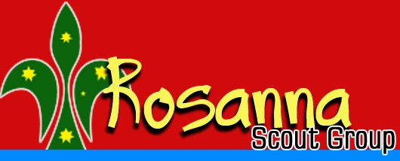

Rosanna Scout Group –
Annual Reports & Awards Presentation Night – Tue 15th Sep

It’s that time of the year for us to hold our ARAP – Annual Reports & Awards Presentation night

Details:
Tuesday 15th Sep – 6:45-7:15pm – Rosanna Scout Hall
All Cubs, Scouts, Venturers and families are invited
Cubs, Scouts and Venturers in full uniform

We’ll have an Investiture for our newest Cubs, one of our Cubs will be going up to Scouts and some badges will be presented.

In addition we’ll be finding out what our Group has achieved throughout the year!

Note that this will lead into our “Monsterology” Cub night for the week

NOTE: Cubs can come in their Monster outfits.... EXCEPT for James M and Gabriel, who will be getting invested, Polina and Matthew v-O, who need to help with the investitures AND Alex W, who’s going up to Scouts. ALL except Alex should bring their costume with them to quickly change into for the Cub night.



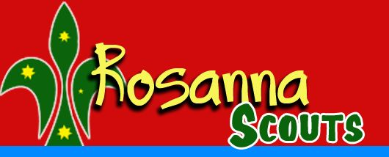
Please come along to see how our Group has progressed in the past year.

